**Chapter 12 -** Money and Banking in the Developing Economy

**Bimetallic Standard** - A monetary system in which a government recognizes coins composed of gold or silver as legal tender. The bimetallic standard backs a unit of currency to a fixed ratio of gold and/or silver.

**Central Bank** - A public institution that manages a state's currency, money supply & interest rates. Central banks also usually oversee the commercial banking system of their respective countries.

**Recession** - A period of slow or negative economic growth (2 consecutive quarters), usually accompanied by rising unemployment.

**American Monetary Unit**

* The dollar or *Reales* (a common name for the Spanish peso) and its sub-denominations were commonly used in commercial transactions along American seaboard and the most abundant form of money and was therefore adopted as the unit of account.

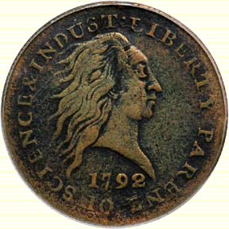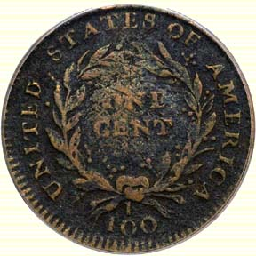

* The new nation needed a stable monetary unit and a banking system that was sound and could supply the needed credit
* Thomas Jefferson, Alexander Hamilton (the first secretary of the treasury), & Robert Morris supported dollar as American Monetary Unit
* This established the decimal system we use today with money – which is much easier than the British system, which was eventually decimalized in 1971.

|  |  |
| --- | --- |
| **Basics** | |
| 12 pennies | = 1 shilling |
| 20 shillings | = 1 pound |

|  |  |  |
| --- | --- | --- |
| **Lsd values were written and pronounced. A few examples:** | | |
| **Amount** | **Written as** | **Pronounced as** |
| two and a half pennies | 2½d | tuppence-ha'penny |
| two and three quarter pennies | 2¾d | tuppence three farthing |
| four pennies | 4d | fourpence |
| two shillings | 2/- | two shillings, or two bob |
| eight shilling and four pence | 8/4 | eight and fourpence |

|  |  |
| --- | --- |
| **Until 1971, the coins in use were:** | |
| Half penny | Known as a *ha'penny* |
| Penny |  |
| Three pence | Known as a *threpney bit* |
| Sixpence | Known as a *tanner* |
| Shilling | Known as a *bob* |
| Florin | = 2 shillings |
| Halfcrown | = 2 shillings and six pence |

* **Coinage Act of 1792** *-* Set our monetary system based upon gold & silver – “*Bimetallic System*” for almost 75 years

Designated both gold and silver as the monetary standard for the U.S. = **Bimetallic Standard** and lasted for almost 75 years

Silver coins contained more metal than gold coins of the same denomination.

Gold (was about 15 times as valuable as silver) would add prestige and serve in higher denominations

Silver would serve for smaller denominations

**Problematic** because the value of the 2 metals fluctuated.

In 1792 = 15:1

In 1790’s = 15.5:1

In 1808 = 16:1

Thus when it was 16:1 the minted gold coin was undervalued so it was better to export gold coins and exchange them for silver and then convert into new coins at the US mint

**Grecham’s Law**: “Money overvalued at the mint tends to drive out of circulation money undervalued at the mint, providing that the two monies circulate at fixed ratios.” “Bad money drives out good money”

Application: students will want to take easy coursed because an A in an easy course counts just as much toward their GPA as an A in a hard course: “Bad courses Drive out Good”

Coins in convenient denominations were hard to find and those that were available were badly worn

**Advantage**

A cheaper metal could replace the dear metal, thus helping to maintain the stock of money and the price level

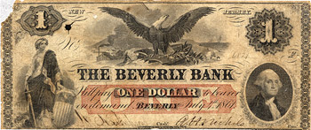**State Bank Notes as Paper Money/Currency**

Virtually no banks during colonial times

Constitution forbade the states from issuing paper money

* + - *Article I, Section 10 US Constitution*

But, states could create corporations

Before 1790 = 3 banks 1800 = 20 1811 = 88

– State governments began to issue bank charters – thus, in 1793 there was a boom in state bank charters

ex. A bank which could then issue their own bank notes (paper money) which were redeemable in silver or gold (*specie*)

Bank notes are similar to a bank deposit

A bank loaned money to its customers, it gave them the proceeds either in its own note (which then circulated as cash) or as a deposit on which they could write checks

Those who accepted bank notes from borrower could present them to issuing bank for gold & silver

**Problems**:

By 1860, there were over 1,500 state banks averaging 6 different note issues & over 9,000 different state bank notes

Were they counterfeits or forgeries?

Was the issuing bank still in business?

Would they redeem the notes at face value or would the notes be worth less than their stated value?

Typically these notes were taken by others at a discount

The amount of discount depended on the distance from the point of issue, how established and reliable the bank was etc

The system encouraged counterfeiting, thus bank formed anti-counterfeiting associations, hired detectives called **snaggers** (men hired to find the makers of spurious bills), Publications like *Bicknell’s & Nicolas, Thompson’s & Hodges, Bank Note Safeguard* were known as Bank Note Reporters and they created lists of true notes and how to ID fake ones (at one point the list contained 5,400 counterfeits!)

**Characteristics of a Central Bank**

1. Lender of last resort to private bankers - should lend freely but at a high interest rate
2. Should have considerable control over the stock of money and use this control to moderate fluctuations in credit conditions, prices, or other aspects of the economy
3. Regulate other banks
4. Lend lots of money to the government

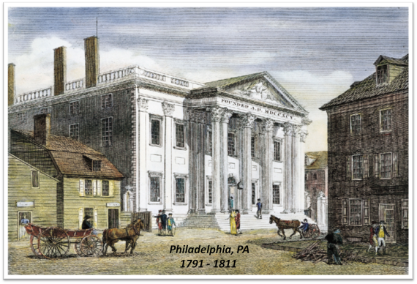**First Bank of the United States created in 1791** by President Washington with a 20 year charter

Robert Morris established and organized the first American Bank in 1781 to help finance the war effort and provide financial organization in those troubled times

Alexander Hamilton argued for a Bank of the United States in a Report on a National Bank

Patterned after the Bank of England to function as a central bank – similar to the Fed today

A national bank would augment “the active or productive capital of a country”

As a country increases its transactions it needs more money to be able to accommodate the business activity

One way to get more money is to export more stuff such that you are paid in money which then will allow for this increase in economic activity

A national bank could issue notes instead

HQ in Philadelphia, PA – Branches in major US cities

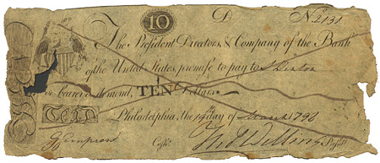Privately managed - Not gov’t controlled

Private Investors included Members of Congress

Issued its own paper bank notes circulated country-wide valid for payment of US taxes

*Bank Note from the 1st Bank of the U.S.*

Could serve as a tax collection agency

Made loans to US Gov’t & private parties

Accepted state bank notes & presented them for gold & silver thus, a creditor of state banks

A national bank could lend money to the US Treasury

Could serve as a fiscal agent for the government by acting as a depository of government funds from one part of the country to another

Could cement the relationship between government and leading business men because the shareholders would be from both

Lender of last resort to private bankers

Involved in Louisiana Purchase

Congress refused to recharter it in 1811 because:

1. It was unconstitutional
2. It would create a money- monopoly that would endanger the rights and liberties of the people = financial monster
3. It favored the commercial North and not the agricultural South
4. US monetary system subject to foreign control

Foreign ownership was about $7 million or 70% of the shares

3/4 of stock owned by foreigners but couldn’t vote for directors

1. Thomas Jefferson, the prior President, said the bank was unconstitutional and a menace to personal liberties and people liked him
2. Personal dislike of Albert Gallatin who was a champion of the bank and the former secretary of the treasury

Charter lapsed in 1811 - Closed doors on March 3, 1811 - Victim of Politics

**Positive Things it did during its 20 years:**

1. Soon after it was created the notes were circulating widely and at, or close to, par
2. State banks used the notes as part of their reserves – economized the use of silver
3. Held a large reserve of silver in its reserves ($15 million – which is about equal to all state reserves)
4. Followed a conservative lending policy

It became a creditor of the state banks (which discouraged the state banks from issuing as many notes as they would have liked bc the National Bank would present the states bank with its note for redemption)

1. Became a lender of last resort
2. Acted as a fiscal agent for the government and held most of the US Treasury’s deposits
3. The bank transmitted government funds from one part of the country to another without a charge
4. Helped collect customs bonds in cities where it had branches
5. Effecting payments of interest on the public debt
6. Carried on foreign-exchange operations for the US Treasury
7. Supplied bullion and foreign coins to the mint

**The Second Bank of the United States** - was charted in 1816-1836

Due to a need for financing the war of 1812 and the sharp inflation after the suspension of specie payment in 1814

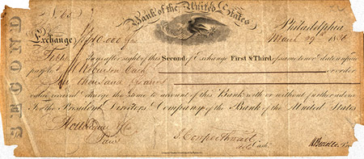HQ in Philadelphia - 25 branches around the country

Functioned as a central bank - Similar to Fed today

Issued its own paper bank notes

Accepted state bank notes & presented them for gold & silver thus, a creditor of state banks

- Some control over money supply but less control than 1st Bank because more state banks existed

*Bank Note from the 2nd Bank of the U.S.*

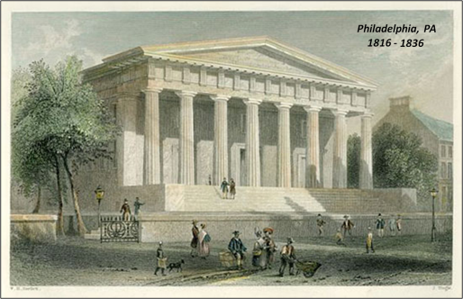 Fiscal agent of Treasury

Made loans to private parties as well as US Gov’t

After President Andrew Jackson vetoed extension of bank charter in 1832, it lapsed in 1836

Nicholas Biddle – 3rd president of the 2nd national bank

Regulated the banking system according to preconceived notion of what ought to be done

Lender of last resort

Kept a much larger specie reserve against its circulation than other banks

Assisted in times of stress by lending to business firms when other banks could or would not

Developed a policy of regularly presenting the notes of state banks for payment

Tried to affect the general economic climate of the US by alternating expansion and contraction of the bank’s loans

Largest dealer in foreign exchange

Protected the US from severe specie drain when a drain would have meant a harmful contraction of monetary reserves

Andrew Jackson

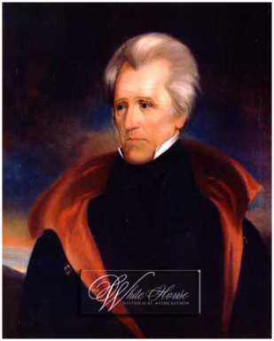 Did not like banks in general and “The Bank” specifically

Began the “Bank War” in his inauguration speech

Unconstitutional

Too much foreign ownership

Domestic ownership was too heavily concentrated in the East

Instrument of the rich to oppress the poor

After President Andrew Jackson vetoed extension of bank charter in 1832, it lapsed in 1836

In 1833 the government discontinued making deposits with the bank

Began withdrawing government funds from the second bank placing them in “pet banks”

Many banks began to expand their paper note issuance recklessly = “wildcat banks”

Biddle responded by contracting loans sharply and presenting the notes of state banks for payment in specie🡪 financial

stringency 1834

Became a state bank of Pennsylvania in 1836

Remained the most powerful financial institution in America for several years

Failed in 1841 due to a bad bet on agricultural prices

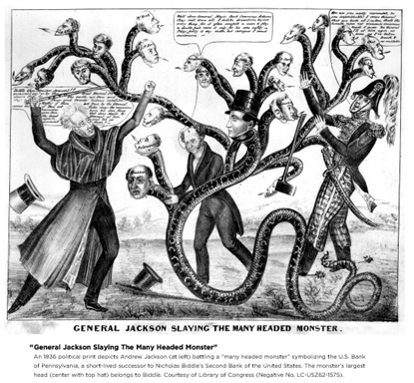

**After 1832 (until late 1913), the US lacked a Central Bank**

*“As direct result, economic disaster would be visited on the United States roughly every twenty years for more than a century.”*

(John Steele Gordon, An Empire of Wealth, pg. 81)

During the same time

There was an influx of Mexican silver (Mexico was having political and economic turmoil)

In flows from England and France raised the amount of specie in the US

The steady outflow to China declined as well

Because the amount of money (specie and bank notes) a bank could issue is limited mainly by the amount of specie they could keep in reserve

 As the amount of specie increased the amount of paper money and deposits increased along with it 🡪 explaining the increase in money and prices

**Experiments in State Banking** - The states tried many varieties of banking styles

Suffolk System

* Private – not state government
* 1824 to 1858 🡪 6 Boston banks joined with the Suffolk Bank of Boston to create a system for presenting country banks with their notes in volume 🡪 forcing them to hold higher reserves of specie
* Country banks agreed to keep deposits in the Suffolk Bank 🡪 1st arrangement of a clearing house for currencies of remote banks
* Country notes passed through the Suffolk system at par 🡪 New England was blessed with a uniform currency
* Became one of the most profitable bank in the country
* Predecessor of our modern day practices of requiring reserve deposits of member banks in the Federal Reserve System

In **1827 New York Safety Fund Act** invoked state regulatory power to increase protection for depositors and note holders

Like FDIC insurance

Stockholders were responsible for debts equal to 2x the value of their stock holdings

The Safety Fund System

* Required new banks and those being re-chartered to hold 3% of their capital stock in a fund to be used as reserves for banks that failed
* Did not prevent the panic of 1837
* Operated similarly to the modern Federal Deposit Insurance Corporation

**Free Banking in:**

1. New York
2. Ohio
3. Louisiana
4. Michigan

* Most important
* New York assembly passed in 1838 stating that any individual or group of individuals, upon compliance with certain regulations, could start a bank
* Increased competition 🡪 improved services and reduction of legislative corruption
* The amount and type of bonds that had to be deposited had a lot to do with the success or failure of the system
  + too much = not enough banks would be set up
  + too little backing = wildcat

**Forstall System**

* Louisiana Law of 1842
* Model of sound and conservative banking
* Required all banks chartered under it to keep a specie reserve equal to 1/3 of their combined note and deposit liabilities

The Economic Consequences of the Gold Rush in 1848

Gold was the basis for the value of money for much of the world’s economy

With an increase in the amount of gold from California and Australia it increased the money supply

US’s money stock rose from 1849 = 100 to a peak in 1856 = 182 🡪 increased at a rate of about 8.5% per year

🡪 created a long economic boom as seen in the increase in GDP and a substantial increase in prices

Expansion ended with a Crises of 1857

Sudden decline in money and in prices

Failure of the Ohio Life Insurance and Trust Company – a large bank with a reputation for sound investing 🡪 shocked the financial community 🡪 led to distrust of banks

🡪 runs on banks

🡪 banks called in loans and refused to make new loans

🡪 sharp recession, increase in unemployment, and New York bread riots